1-> API invoke by Lamda

Integrate Lamda1 with API Gateway

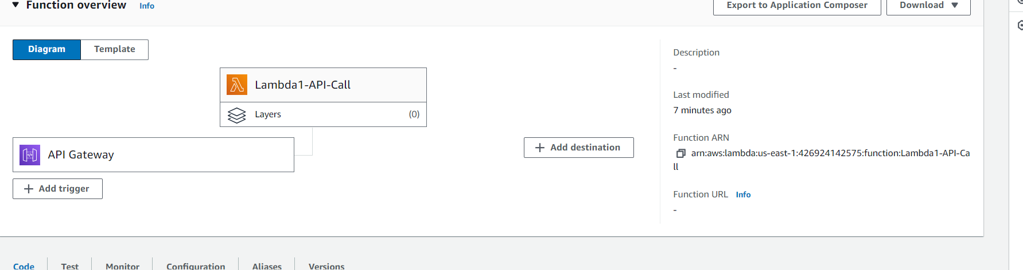

import json

def lambda_handler(event, context):

# TODO implement

return {

'statusCode': 200,

'body': json.dumps('Hello from Lambda1-api call to check!')

}

* Create rest API and create method

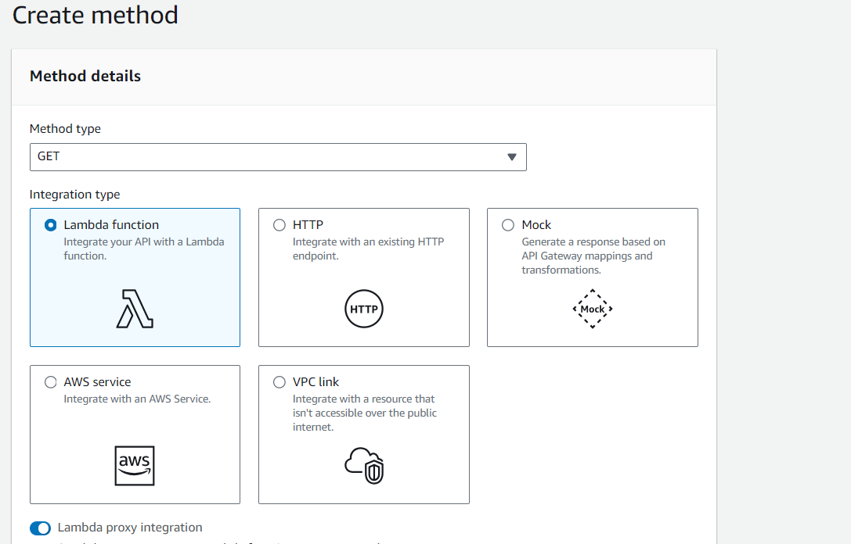

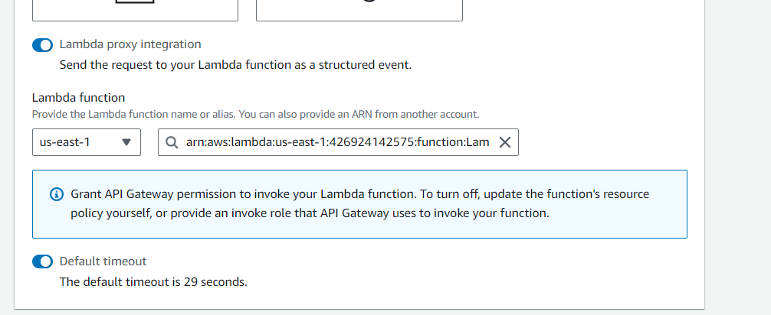

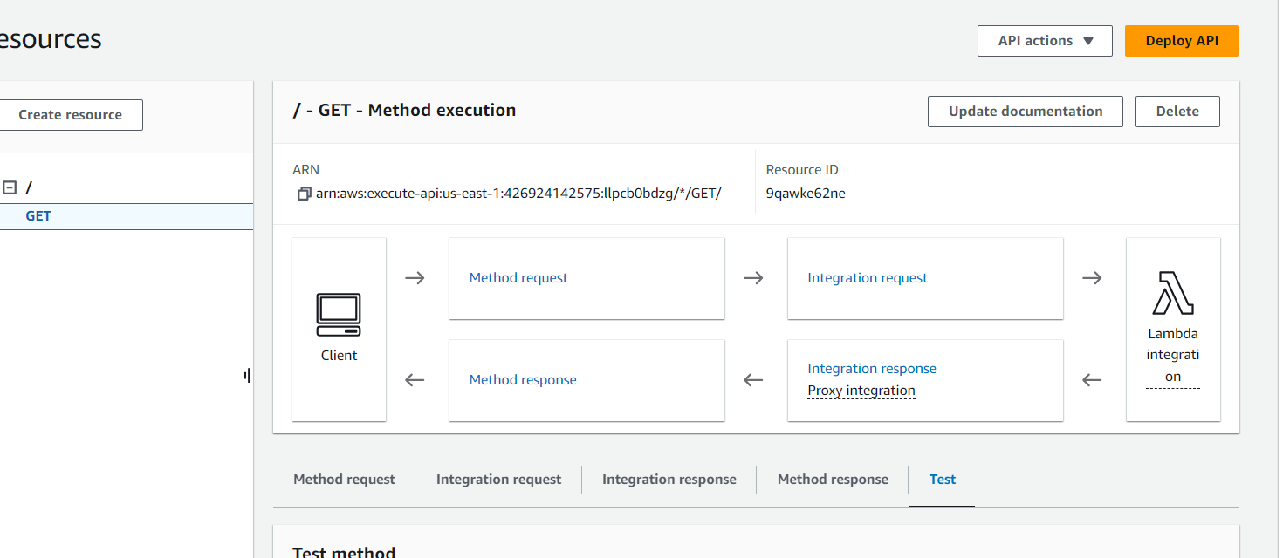

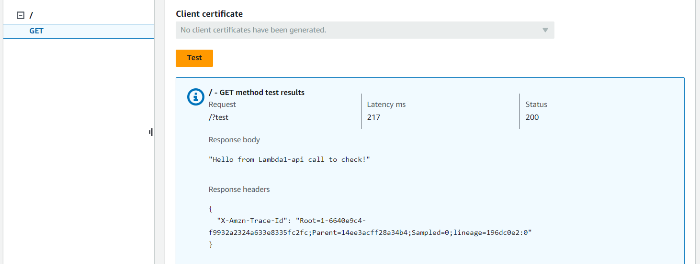

Create another resource

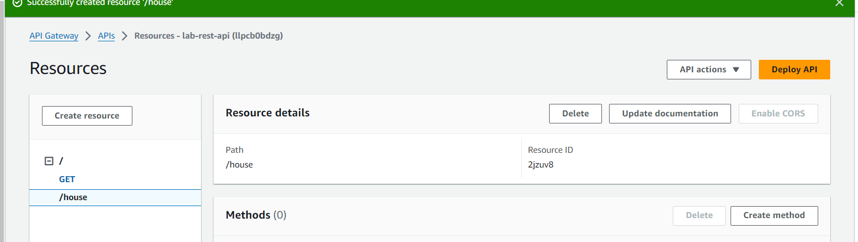

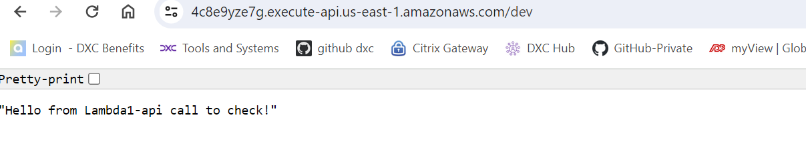

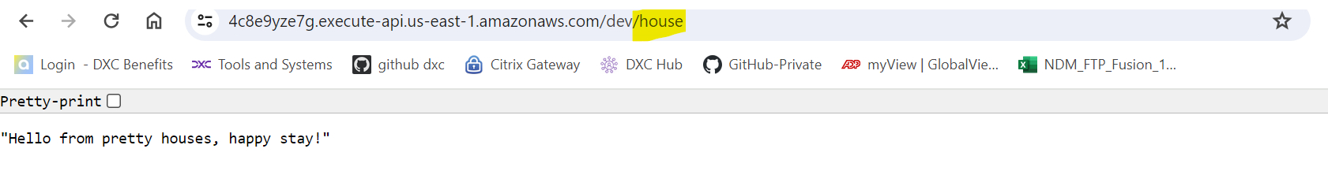

Different version of same Lambda is getting published by

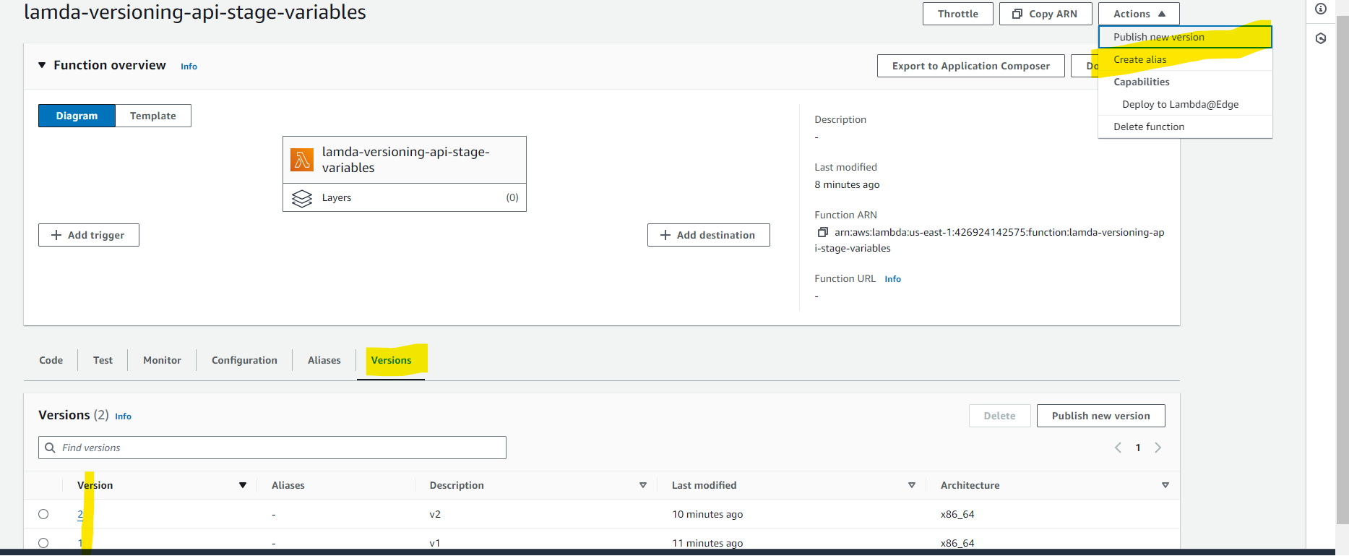

Add current version as alias and routing to different version is optional.

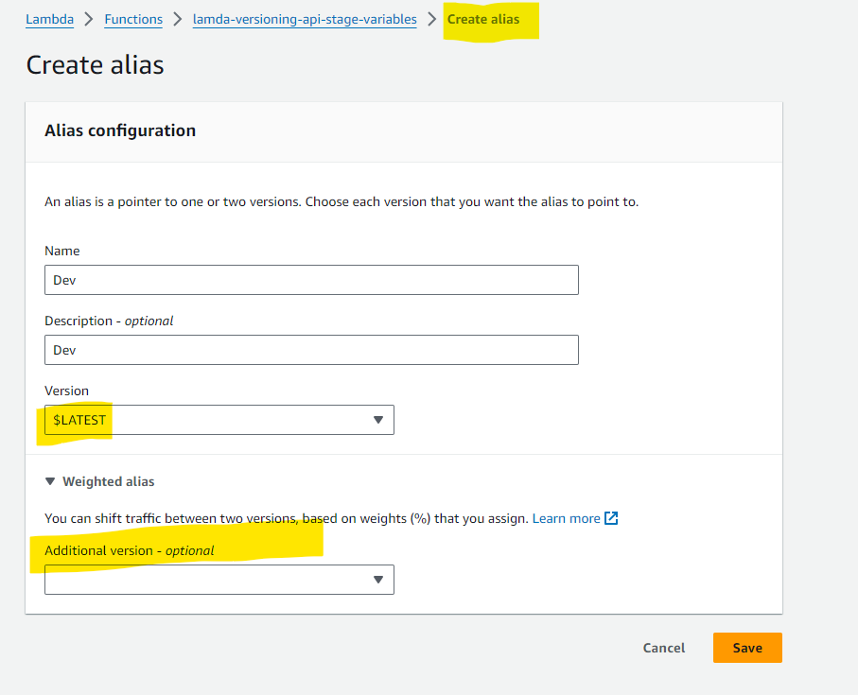

Alias with different version of the code.

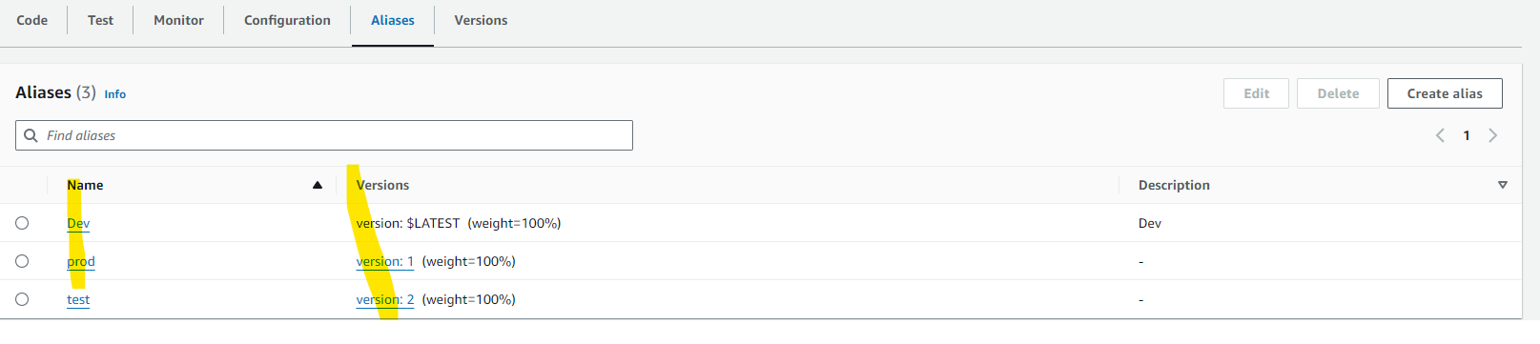

At end of arn – add :${stageVariables.lamdaAlias}

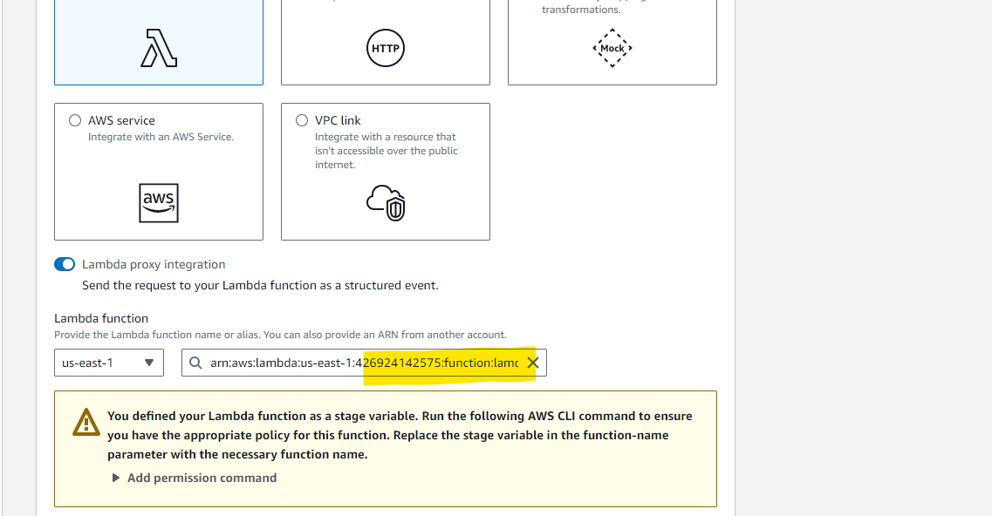

aws lambda add-permission \

--function-name "arn:aws:lambda:us-east-1:426924142575:function:lamda-versioning-api-stage-variables:${stageVariables.lambdaAlias}" \

--source-arn "arn:aws:execute-api:us-east-1:426924142575:mza6uvwje2/*//house" \

--principal apigateway.amazonaws.com \

--statement-id e0442f3f-7102-4b56-adec-16c03fd2530a \

--action lambda:InvokeFunction

Updated one

aws lambda add-permission \

--function-name "arn:aws:lambda:us-east-1:426924142575:function:lamda-versioning-api-stage-variables:prod" \

--source-arn "arn:aws:execute-api:us-east-1:426924142575:mza6uvwje2/*//house" \

--principal apigateway.amazonaws.com \

--statement-id e0442f3f-7102-4b56-adec-16c03fd2530a \

--action lambda:InvokeFunction

